Principal Components Analysis
Generated: 2026-05-28 18:50:48

Scores
Index | PC1 | PC2 | PC3
0 | 0.33948180569436265 | 0.9909537959561802 | 1.039022867737854
1 | 0.81002088104764 | -2.2526189431771644 | -0.7256877446312326
2 | 1.3049505256215341 | -0.10522788280134483 | 1.4453649008140412
3 | 1.6085847525686152 | -0.6118140853928193 | 1.222520726800179
4 | -1.1487274830224132 | -0.47867151745993153 | -2.397843543401251
5 | -2.985321168448104 | 2.019582310475207 | 0.27629538139111615
6 | -0.28869736448336186 | -0.8906618714004425 | -1.9733561735625424
7 | -1.4283007874982063 | -0.06275052361567338 | 1.3886317467425833
8 | 0.9895960836173878 | 1.482511115198885 | -1.3060867906003482
9 | -2.795198209325636 | -1.171917753698353 | -1.12210149810405
10 | 1.149611305496497 | 1.5616068999494173 | 0.867725579859811
11 | -1.4742277010620413 | -1.533297350279063 | -0.5235031049474927
12 | 0.6039223665181815 | 1.7862633560775492 | -1.3454334901198186
13 | -1.3605180006246835 | 0.2227663473124436 | 1.9133619618172986
14 | -0.6821698539018984 | -1.9450631106725702 | 0.40866506712736045
15 | 0.19282123459488745 | -0.3835993526283364 | -2.164854990216877
16 | 0.7538199906007901 | -0.02950179741261714 | -1.5127419567271922
17 | 0.20659453535978434 | 2.5380300900946726 | 0.03596073455645826
18 | 1.656237557018292 | -1.7107937961168203 | 1.1162649149860924
19 | 1.8918874764403817 | 0.5204902814107863 | -0.005375117271086583
20 | 1.9018259841880363 | 0.056462752557063636 | 0.4575585705259424
21 | -1.5149056986470442 | -0.39825091050905637 | 2.1438295816322306
22 | -0.6034734357343784 | -1.2525972601180848 | -0.15338004156245919
23 | -0.7276066184299129 | 2.171748037474504 | -0.2521058981387039
24 | 2.5651239206729035 | 0.1968750669488654 | -1.0144016589978004
25 | -0.9746633168509793 | -1.1863788009156808 | 0.3482601496762864
26 | -0.22222867703056498 | 0.9362177633074192 | 0.474900360468663
27 | 1.355396232162198 | -1.1141386452860014 | 0.6328652750425552
28 | -0.1260101949114355 | -1.061498077558569 | 0.7733117132901741
29 | -0.9978261416308339 | 1.7052738622795287 | -0.04766752418779083

Components
Index | How satisfied are you with your recent experience? | On a scale of 1–5, how satisfied are you with the product? | Does this service meet your expectations overall? | How positive or negative do you feel about this brand? | Do you agree or disagree: “This feature is very useful”? | What is your overall impression of the new policy? | How reliable do you perceive this product to be? | Does this company seem innovative to you? | How affordable do you think this service is?
PC1 | 0.33499437872360543 | 0.38688873527242706 | -0.3295137990061155 | -0.13151783623518812 | -0.4497940760541339 | -0.17815486810276943 | -0.09156546164773295 | 0.5126616961511757 | -0.32704658905114514
PC2 | 0.3814864657038238 | -0.16040467167720812 | 0.26881530669761233 | -0.32301714917714464 | -0.36520922046141624 | 0.520744339997663 | 0.34205437844111325 | 0.10407979884884473 | 0.3460497440003109
PC3 | 0.36952790537927754 | 0.49400197097279447 | 0.46585101473191926 | -0.3345342182514708 | 0.15648715152788728 | -0.32277834057586746 | -0.16375347521121297 | -0.36092031634053107 | 0.06876123605487272

Loadings
Index | PC1 | PC2 | PC3
How satisfied are you with your recent experience? | 0.4679562683192865 | 0.5047318848475378 | 0.44449309482116145
On a scale of 1–5, how satisfied are you with the product? | 0.5404479009548698 | -0.21222601468866792 | 0.5942188985702639
Does this service meet your expectations overall? | -0.4603004036370346 | 0.3556604719253474 | 0.5603570291971277
How positive or negative do you feel about this brand? | -0.1837182943085275 | -0.42737310284773317 | -0.40240032709181384
Do you agree or disagree: “This feature is very useful”? | -0.6283208636049332 | -0.48319601028861076 | 0.1882333032764765
What is your overall impression of the new policy? | -0.24886592896853307 | 0.6889792846668558 | -0.38825956431233
How reliable do you perceive this product to be? | -0.1279085096975883 | 0.45256061924087704 | -0.19697372762591417
Does this company seem innovative to you? | 0.7161411339354969 | 0.13770447386805798 | -0.43413930601364453
How affordable do you think this service is? | -0.4568539387498112 | 0.4578467527492527 | 0.08271065370932816

Fit Metrics
Index | Metric
0 | Explained Variance: 0.2096, 0.1880, 0.1554
1 | Singular Values: 7.5226, 7.1249, 6.4776
2 | Noise Variance: 0.6936

Visualizations
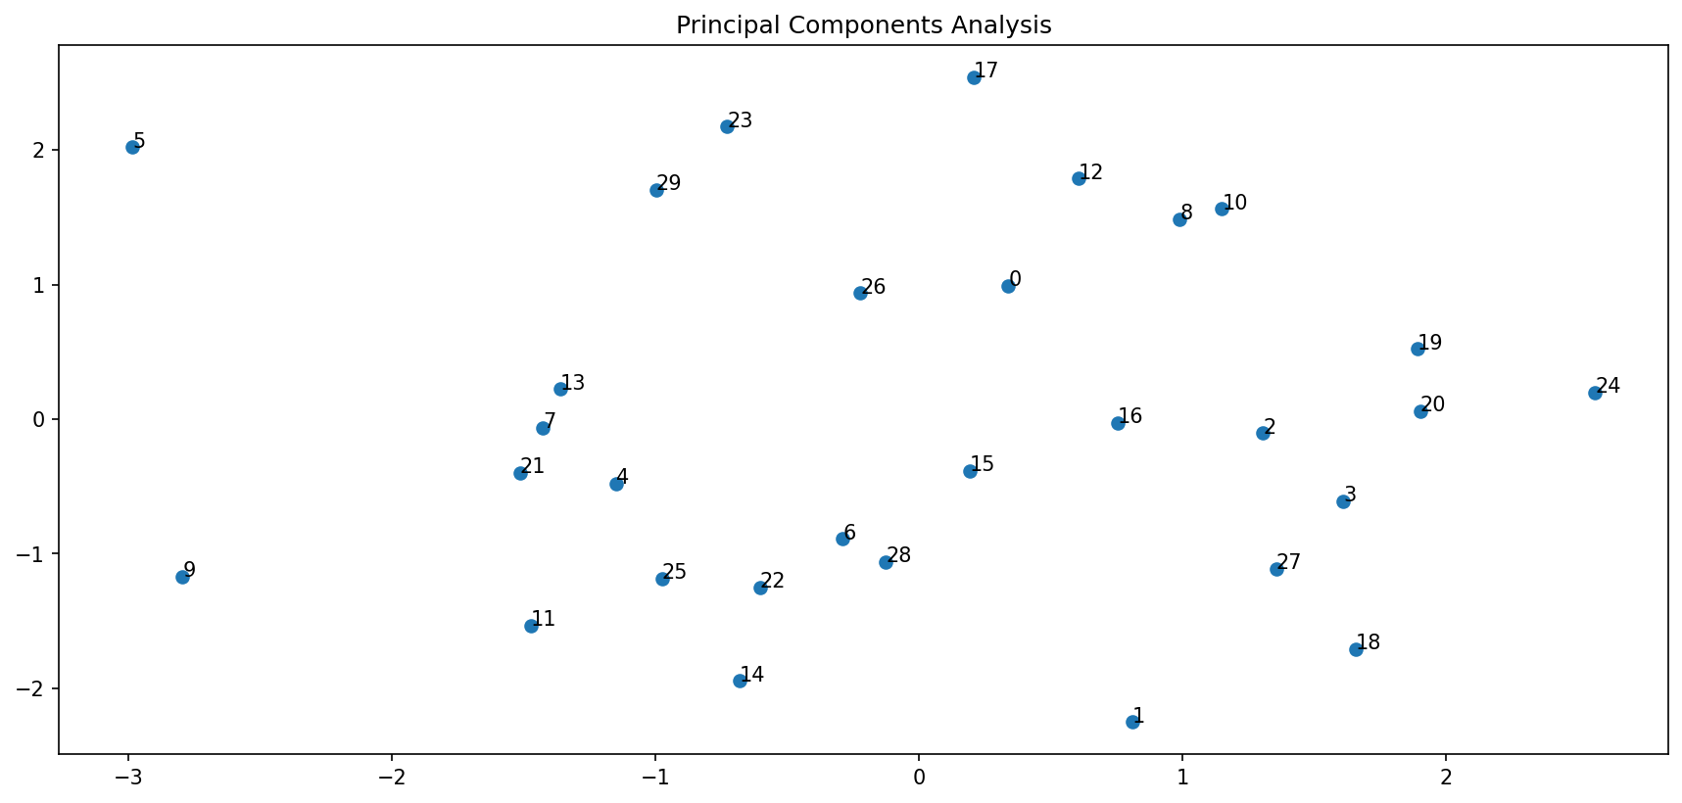
Figure 1

